الاسم : اسراء جمال محمد حماد

الكود: 190018

Human Computer Interaction

### 1. [NYU](https://www.nyu.edu/" \t "https://blog.hubspot.com/website/_blank)

****What it got wrong****: Color

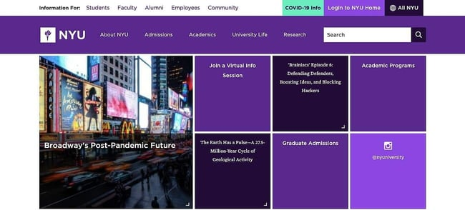

NYU's homepage has three major components — a navbar, a body section with a unique grid layout, and a footer — all of which are purple. Although they are slightly different shades of purple, there's not much contrast, so separating one section from another is difficult. This is confusing and makes navigating the site more difficult.

Also, since the grid layout has some images but is mainly blocks with a solid background color and some text, it looks like the web page isn't fully loaded. More pictures would help prevent this misconception and provide valuable context to readers.

How to Improve: NYU should improve the contrast on its website. While the grid layout is unique, it makes the site feel squeezed and slightly claustrophobic. The site could benefit tremendously by using visual hierarchy principles instead of a grid and using color more sparingly.

**<https://www.nyu.edu/>**

### 2. university of advanced technology

****What it got wrong****: Lots of animations and high-resolution images

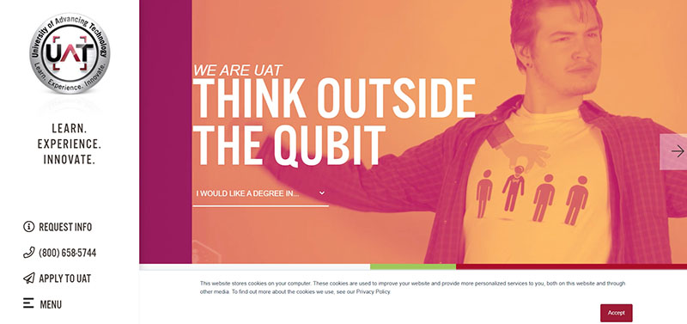

This design isn’t the worst case, but we included it in this list because of its bad usability. When the main page loads longer than 40 seconds, this indicates obvious technical problems that inevitably affect the user experience. Lots of animations, numerous high-resolution photos, and an outdated programming approach are the key reasons for the various issues this website has. Despite all this graphic splendor, the main page doesn’t include the necessary information. A well-thought-out navigation menu is probably its only advantage.

<https://www.uat.edu/>

### 3. [University of Louisiana](https://www.louisiana.edu/?hubs_content=blog.hubspot.com%2Fwebsite%2Fbad-vs-good-design&hubs_content-cta=Bad%20Website%20Design%3A%20Ecommerce" \t "https://blog.hubspot.com/website/_blank)

****What it got wrong****: Complex drop-down navigation

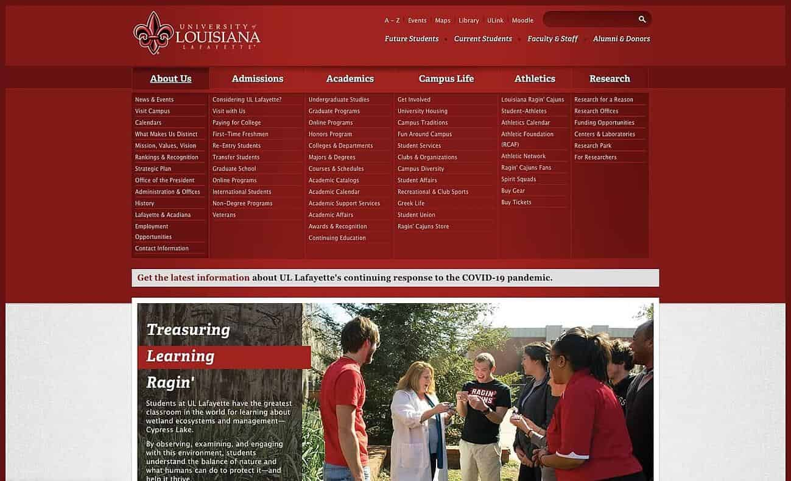

The University of Louisiana has a lot of online resources to offer, so it makes sense to have a drop-down navigation menu. But the design doesn't provide a clean and readable list of items.

The font is small, there's not much spacing between items, and the menu color is very similar to the header background. When a user hovers over an option, the whole column changes to a slightly darker red instead of the individual choice. As a result, the user will likely feel overwhelmed by the possibilities presented instead of guided.

How to Improve: the University of Louisiana could make the website significantly more accessible by simplifying the drop-down navigation menu.

**<https://louisiana.edu/>**

### 4. [Yale School of Art](https://www.art.yale.edu/" \t "https://blog.hubspot.com/website/_blank)

### ****What it got wrong****: Inconsistency

### IMG_256

While an animated background can add more personality and depth than a solid background, Yale's speed and glitch effect distract from the rest of its content. The inconsistent use of colors, fade effects, borders, and font styles (uppercase, lowercase, italicized, bold, underlined, and regular font) is distracting.

How to Improve: Yale should focus on creating a website that doesn’t negatively affect user experience. We recommend that it removes the distractions that affect readability.

**<https://www.art.yale.edu/>**

### 5. University of Mississippi

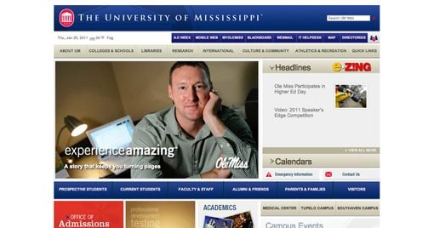

<https://olemiss.edu/>